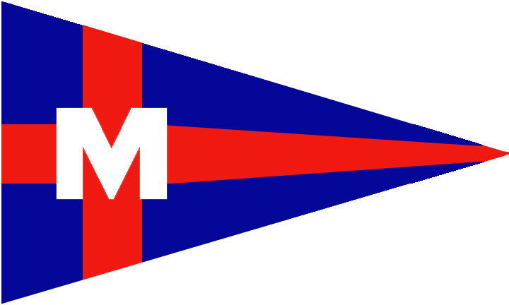
Monroe Boat Club Sailing Fleet
55nd Annual –SISTERS RACE

2022 SAILING INSTRUCTIONS
1. RULES
The race to be governed by the rules as defined in the 2021-2024 Racing Rules of Sailing (RRS), PHRF-LE Class Rules, and these sailing instructions. Each yacht must conform to the USCG requirements for their vessel.

2. NOTICES TO COMPETITORS
Notices to competitors will be posted on the official Sail Fleet notice board located in the rear corridor of MBC and the nearest waterside window of the club.

3. CHANGES TO SAILING INSTRUCTIONS
Any change to the sailing instructions will be posted on the official notice board not later than one hour before the affected race.

4. SIGNALS MADE ASHORE
Signals made ashore will be displayed from the flagpole located near the waterside of MBC. When flag AP is displayed ashore, “1 minute” is replaced with “not less than 60 minutes” in the race signal AP.

5. SCHEDULE OF RACES
5.1 Saturday, July 16, 2022, ONE (1) Race will be sailed. The scheduled time for the warning signal will be at 9:55 am.
5.2 There will be NO competitors' meeting.

6. CLASS FLAGS AND ORDER OF STARTS
Classes will start in the following order and at these approximate starting times:
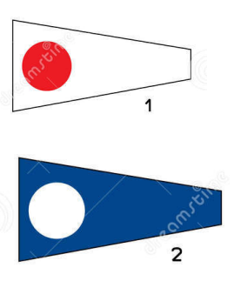 | 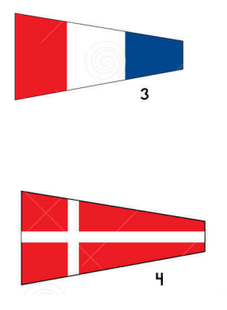 | Warning Signal: 09:55 am  CLASS FLAG CLASS TIME COURSE  #1 JAM B 10:00 am SHORT  #2 JAM A 10:05 am SHORT  #3 PHRF B 10:10 am LONG  #4 PHRF A 10:15 am LONG

On-water postponement: Code Flag "AP" and two sound signals. The Warning Signal will be made one minute after lowering the "AP" flag.

7. RACING AREA
The racing area will be in western Lake Erie.

8. THE START
Races will be started in accordance with RRS 26 with the warning signal given 5 minutes before the starting signal. The starting line will be between an orange flag on the R/C boat and the NCYC Center racing mark. Boats whose class flag has not been displayed shall avoid the starting area.

9. COURSES
PHRF COURSE (LONG): Start at NCYC Center racing buoy, leave the NCYC East racing buoy to port, round the Monroe Channel G1 to starboard, round the Toledo Channel R-10 to starboard, round the NCYC South racing buoy to port, round the Toledo Harbor Light to port, and finish at NCYC North racing buoy. For scoring purposes this course is considered to be 23.2 nm.

JAM COURSE (SHORT): Start at NCYC Center racing buoy, leave the NCYC East racing buoy to port, round the Monroe Channel G1 to starboard, round the Toledo Channel R-10 to starboard, and finish at NCYC North racing buoy. For scoring purposes this course is considered to be 15.9 nm. Competitors on this course are NOT eligible for Overall Trophy.

10. THE FINISH
The finish line will be between an orange flag on the R/C boat and the North racing mark unless shortened or abandoned (See RRS 32).

11. MARK LOCATIONS (these locations are approximate and not necessarily in rounding order)

PHRF:

NCYC Center racing buoy NCYC East racing buoy Monroe Channel G-1 Toledo Channel R-10
41' 49.457 N, 83' 21.842 W 41' 49.457N, 83' 19.961W 41' 52.517 N, 83' 16.864 W 41' 47.750 N, 83' 15.354 W

NCYC South racing buoy Toledo Harbor Light NCYC North racing buoy
41' 48.048N, 83' 21.843W 41' 45.711 N, 83' 19.741 W 41' 50.867N, 83' 21.841W

JAM:

NCYC Center racing buoy NCYC East racing buoy Monroe Channel G-1
41' 49.457 N, 83' 21.842 W 41' 49.457N, 83' 19.961W 41' 52.517 N, 83' 16.864 W

Toledo Channel R-10 NCYC North racing buoy
41' 47.750 N, 83' 15.354 W 41' 50.867N, 83' 21.841W

12. RECALLS
The R/C boat will fly Code Flag “X” or “First Substitute” and signal in accordance with Rule 29, and MAY attempt to notify individual yacht(s) by hail. However, failure of a yacht to hear her recall shall not relieve her of her obligation to start correctly.

13. TIME LIMIT
There will be no time limit.

14. PROTESTS AND REQUESTS FOR REDRESS
Protest flags must be flown. Hearing Request forms (formerly “Protest Forms”) must be provided on paper by the competitor and are available for download here: https://cdn.ussailing.org/wp-content/uploads/2018/04/US-Sailing-2017-2020-Protest-Form.pdf
Hearing Requests shall be delivered to the MBC Sail Fleet Board folder within 1.0 hour after the race committee/finish boat docks. Forms are also available from the Sail Fleet Bulleting Board at Monroe Boat Club.

The protesting yacht must notify the R/C boat at the finish line of their intent to protest and the sail number of the protested yacht. Hearings will be held as soon as possible after racing in MBC Commodore's Room. All interested parties must be present. A boat that has taken a penalty under RRS 31.2 or 44.1 shall notify the Race Committee after it has finished the race.

15. SCORING
The Low Point System of Appendix A of the RRS will apply.

16. SAFETY
Each competitor is responsible for the personal safety of him/herself, his/her crew and yacht. It shall be the sole and inescapable responsibility of the skipper and crew of the yacht to decide whether or not to start, continue, or finish a race. All yachts shall follow the U.S. Coast Guard requirements for carrying lights at night.

Retirement: A yacht that retires shall notify the Race Chair, verbally, via mobile phone (419-356-9394, leave message or sms with yacht name and # ), or using VHF channel 71, before leaving the racing area. If that is not possible, the yacht shall notify MBC as soon as possible. The club monitors VHF channel 16. Club telephone: (734) 243-8935.

17. RADIO COMMUNICATION
Each boat shall have onboard an operating VHF radio, capable of both transmitting and receiving, and shall monitor Chs 16/71 while racing. This is the only method to immediately broadcast potentially life and/or property saving information to the entire fleet and other potential responders at once.

18. TROPHIES AND PRIZES
Winners will be announced and flags/trophies awarded following protests and scoring in the MBC Pavilion. Flags will be awarded to the top three finishers of each class (typically of five competitors). Additionally, a Perpetual Trophy is awarded to the top finisher in PHRF.

19. CHAMPIONSHIP SERIES
This race counts toward the AYC Championship Series and the PHRF Lake Erie Championship Series.

